DA Launches

Public Safety Campaign

**On Tax Scams**

*Issues Pamphlets to Warn the citizens of Tax Scams*

Harris County District Attorney Devon Anderson launched a public safety campaign today to draw attention to tax scams as millions of area residents prepare their returns. The informational pamphlet describes common tax scams as well as what is being done by the IRS and the District Attorney’s Office to investigate and prosecute thieves. Information is also provided to help the public find a reliable or trusted tax preparer.

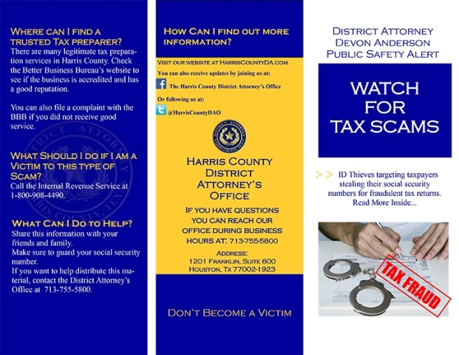

The pamphlet is available in English and Spanish. It can be printed from the [Harris County DA Website](http://www.harriscountyda.com/) or citizens can stop by the District Attorney’s Office to receive copies to hand out at businesses or organizations.

“Before you file your taxes, do your research and make sure the person you are giving your social security number to is a trusted tax preparer,” said D.A. Anderson. “Taking the time now to do that research could save you time and money later from the damages of identity theft.”

The public safety campaign is timely as citizens receive their W-2 forms in the mail and get ready to file their taxes. In 2013, the IRS initiated approximately 1,492 identity theft related criminal investigations, an increase of 66 percent over 2012.

“Tax return fraud is a common economic crime that we see this time of year, not only here in Harris County but across the country,” said Assistant District Attorney and Chief of the Organized Crime Section Ed McClees. “Criminals look at tax season as an opportunity to use your identity to steal from both you and the United States Treasury.”

To avoid becoming a victim:

* Do not give out your social security number just because someone asks for it. Only give it to someone when you are required.
* Protect your financial information.
* Check your credit report every 12months.